Help guide 2: How to upload in assignments on Teams using the school website link on a device/laptop or desktop (a photo, worksheet or new document)
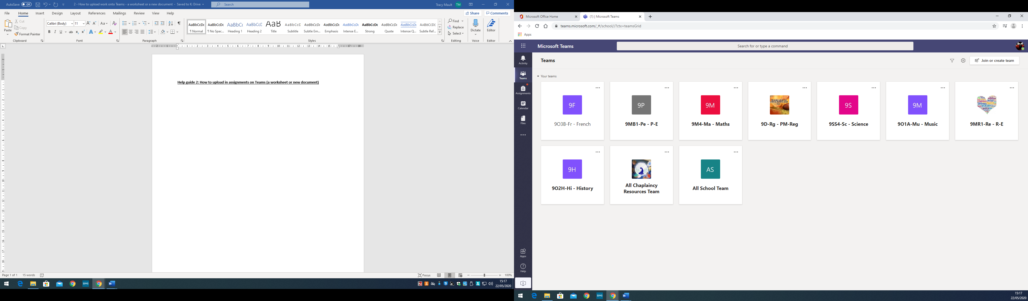
Once a pupil has entered Teams in the way explained in the help guide number 1. Pupils will be able to see all of their classes on the main page.
Pupils are to click on the subject or Team they are doing the work for.

Once a pupil has entered the specific subject Team they are taken to the General page within that area.
On the left hand side there are channels with the work set for each week. These channels are entitled ‘week beginning…’. Pupils will need to access these channels to view the work that is being set and the files teachers have uploaded to help pupils learn. PLEASE DO NOT EDIT THESE FILES AS THEY ARE FOR THE WHOLE CLASS TO VIEW.

However to submit work pupils need to click on the assignments function at the top of the page.

At the top of the page click on assignments. All of the assignments set for pupils to upload work will be in this area.

Pupils are to click on the relevant assignment for the lesson. This should be identified by the date. If a pupil has a new assignment then it is at the top and will be given a due date, and if a pupil has completed an assignment it goes into the bottom area under completed.
Click on the relevant assignment which needs to be completed.

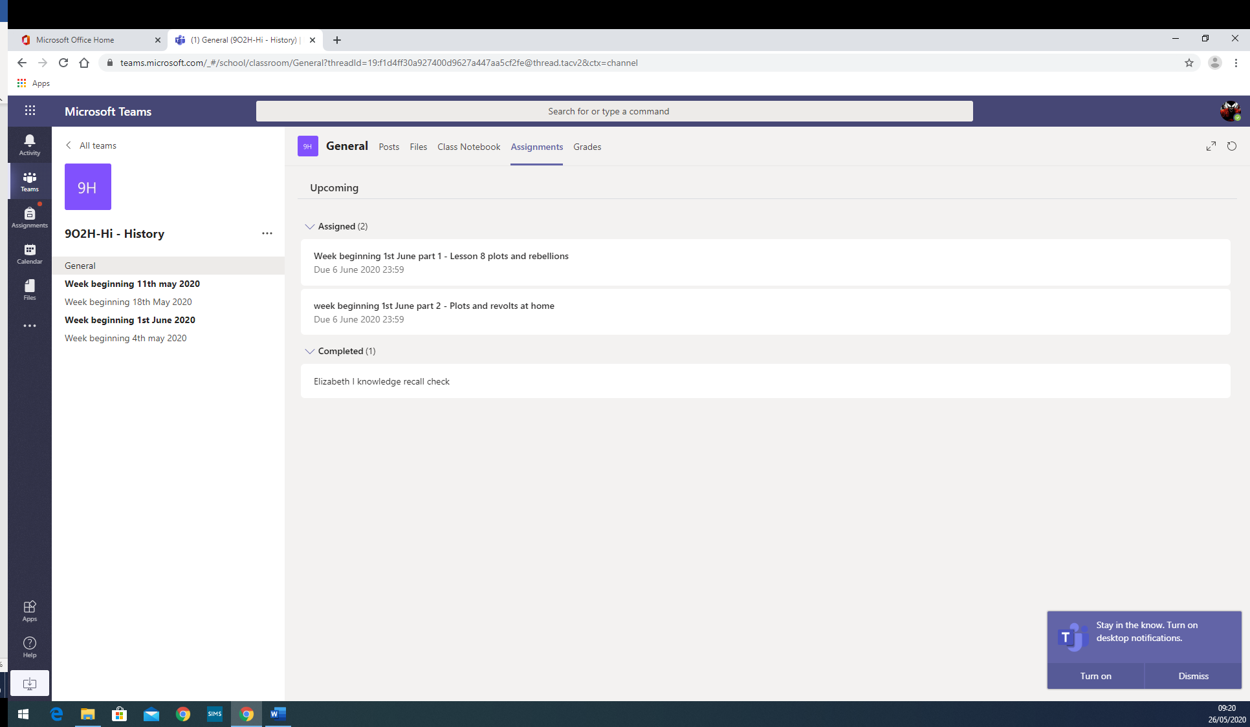

Once the pupil has clicked on the relevant assignment which needs to be completed, the teachers instructions will appear. This will tell the pupil want is needed. This could be completion of a worksheet where pupils write on the document in this area, it could be pupils uploading a word document or powerpoint that a pupil has created or it could be a photograph of a piece of work a pupil has completed on paper or in their exercise books. This will be directed by their teacher. Pupils are expected to upload this by 8am the next day.

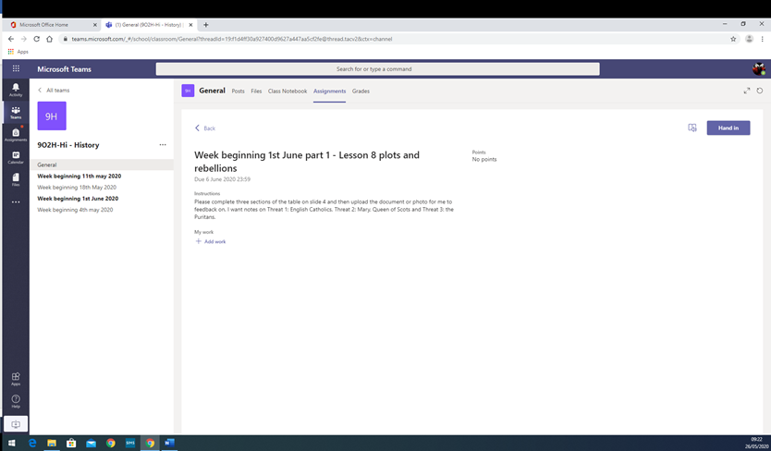
Once the pupil has completed the work they can upload it be clicking on add work. The screen below will then appear.

Pupils can then search for their file through their one drive link if they have saved it in that area or if the file is saved on their computer or on a pen drive/USB then pupils click upload from this device at the bottom of this box (screen shot below). Once they have selected the relevant file they click open.

However, if they are creating a new word document or powerpoint to upload from new then pupils click New file (screen shot below).
Pupils choose a Word document, a PowerPoint Presentation or Excel file as directed by the teacher. They will then be asked to give the document a name. They then click Attach in the bottom left hand corner.

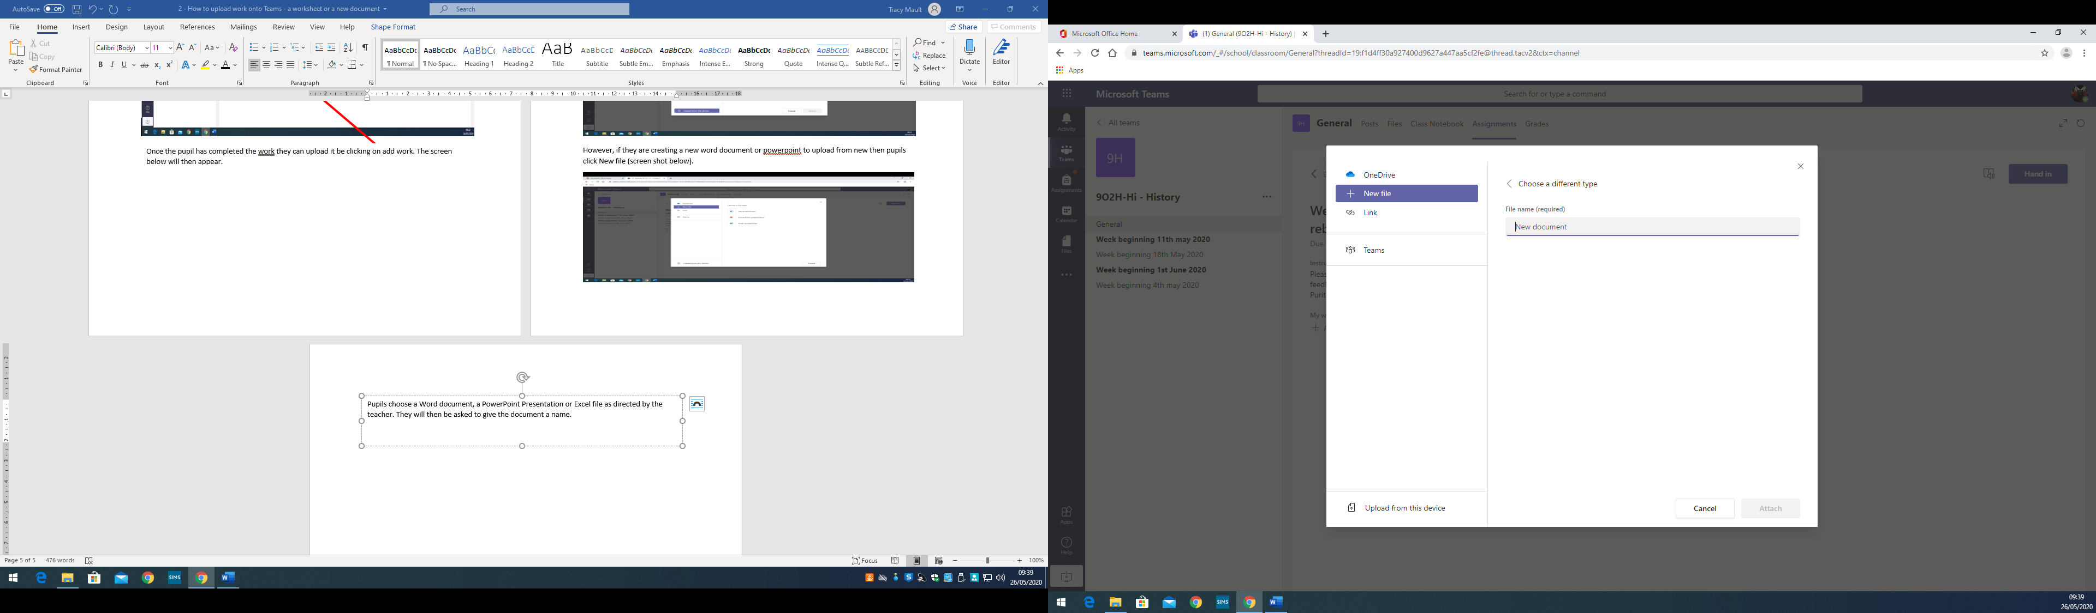
Pupils MUST then click hand in in the top right hand corner for the work to be submitted to the teacher for feedback.

After a teacher has given feedback on the work they will return it to the pupil. If a pupil clicks on the completed assignment link their feedback for each assignment will be on the screen.

