**Help guide 3: How to upload in assignments on Teams using the Teams App on a device/laptop or desktop (a photo, worksheet or new document)**



On their device, pupil are to download the Teams App. This is free and can be found easily in their App store.

The icon looks like this.

Their log in details are their SCHOOL email and password. The same ones used to access their Microsoft 365 area. Please see help guide 1.

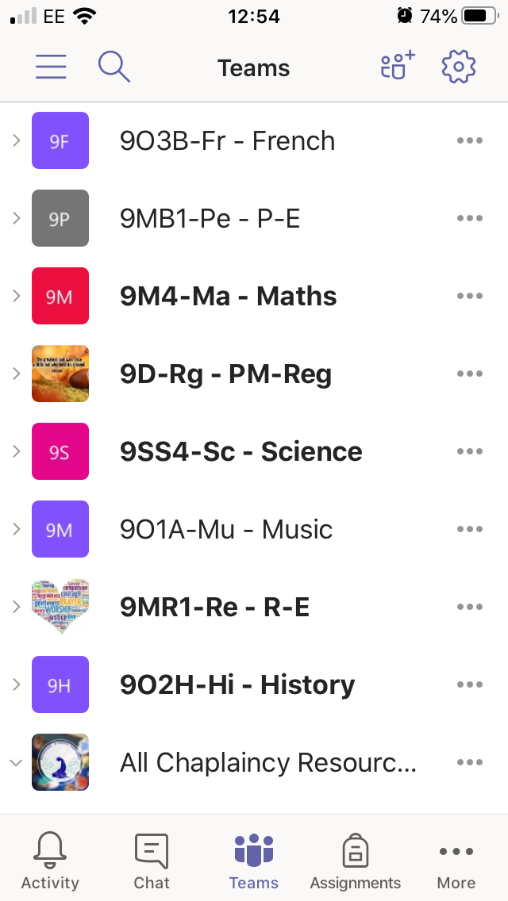

Once they log on to the app then they will see all of their Teams, they should have a Team for all of their subjects.

However at the bottom of the screen pupils are to click on assignments.

They can scroll down or search to find the correct subject they are working on. For example History.

They then choose the assignment they wish to complete.

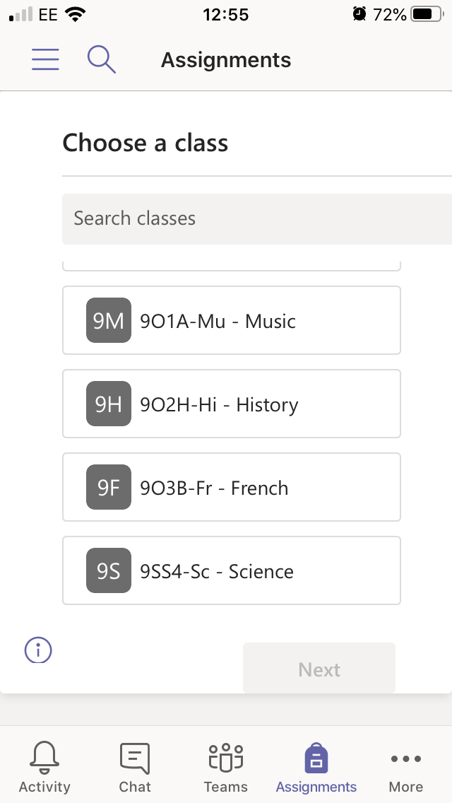

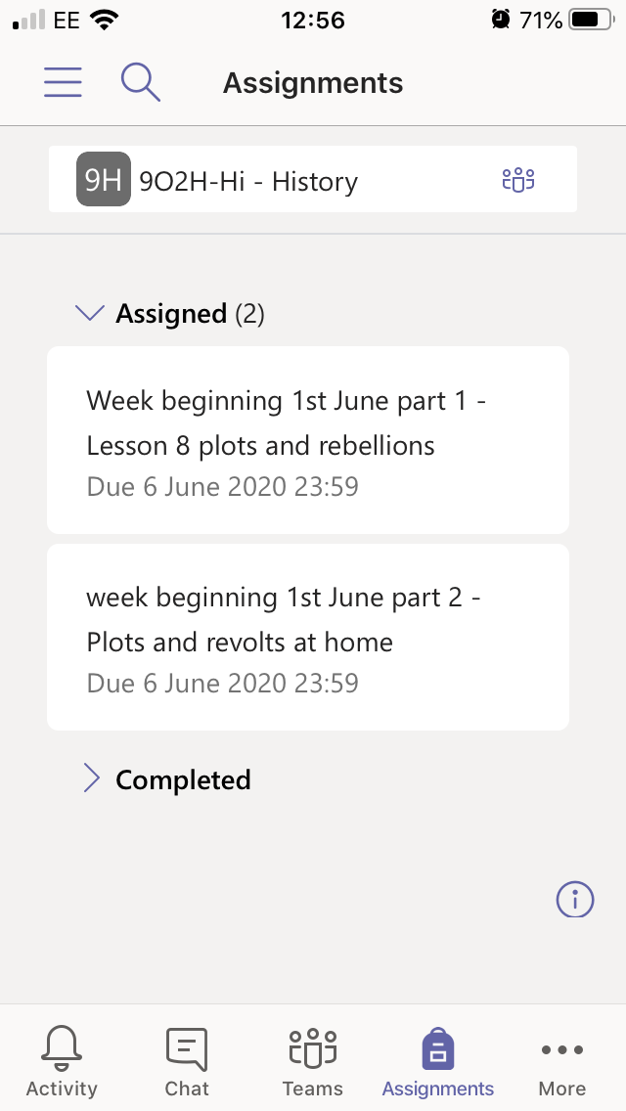

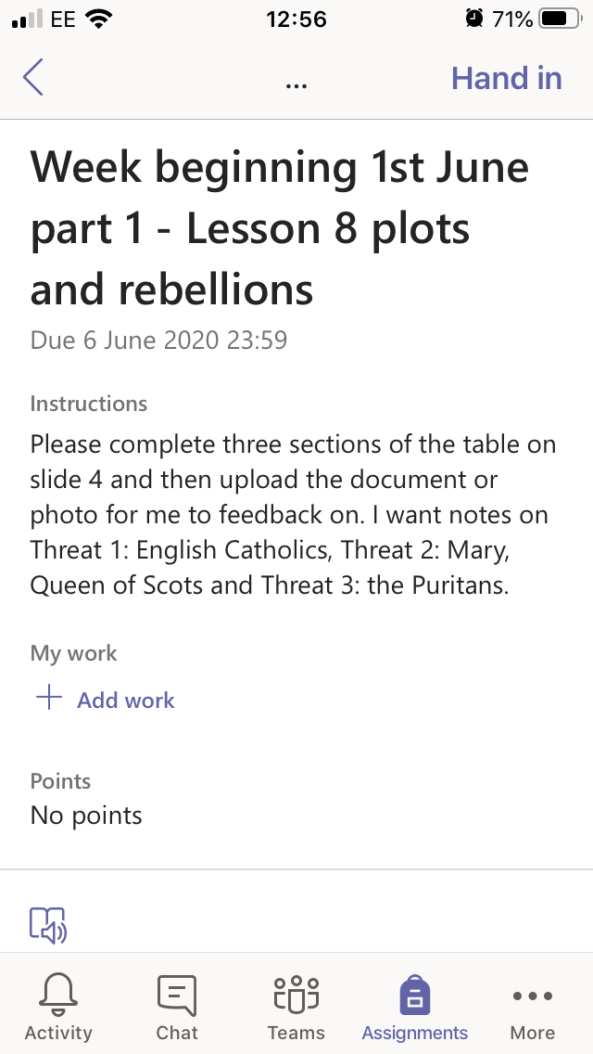

Once they have clicked on the correct assignment, the teachers instructions of what to upload will appear.

The lesson information will appear in the channels for the relevant weeks but this is where pupils will up[load their completed work.

To add work pupils click on ‘+ Add work’

This screen will appear.

If pupils want to upload a NEW DOCUMENT on word or powerpoint they click ‘+ New file’

If pupils wish to take a photo of work and upload that they click on ‘Upload file from this device’

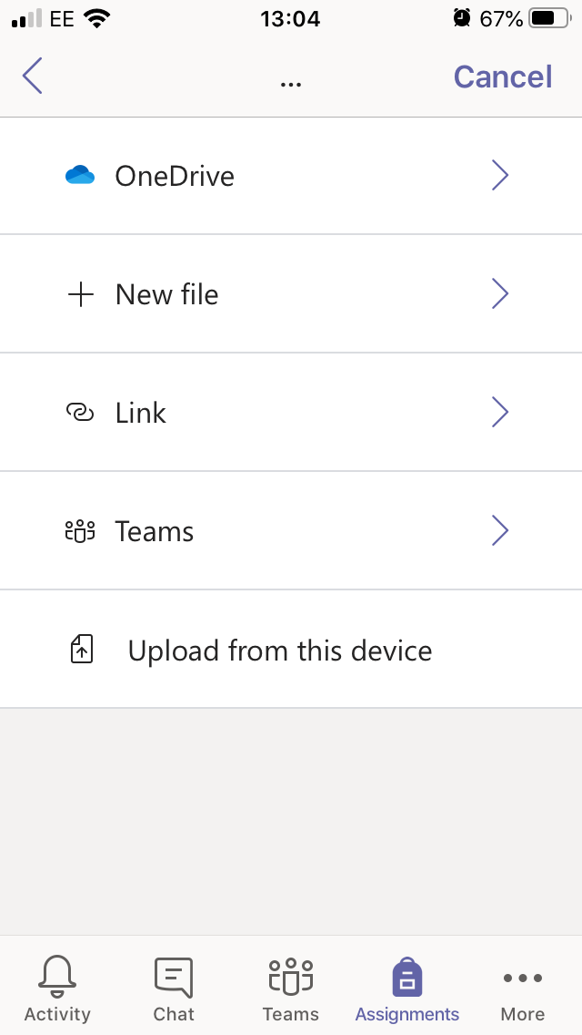

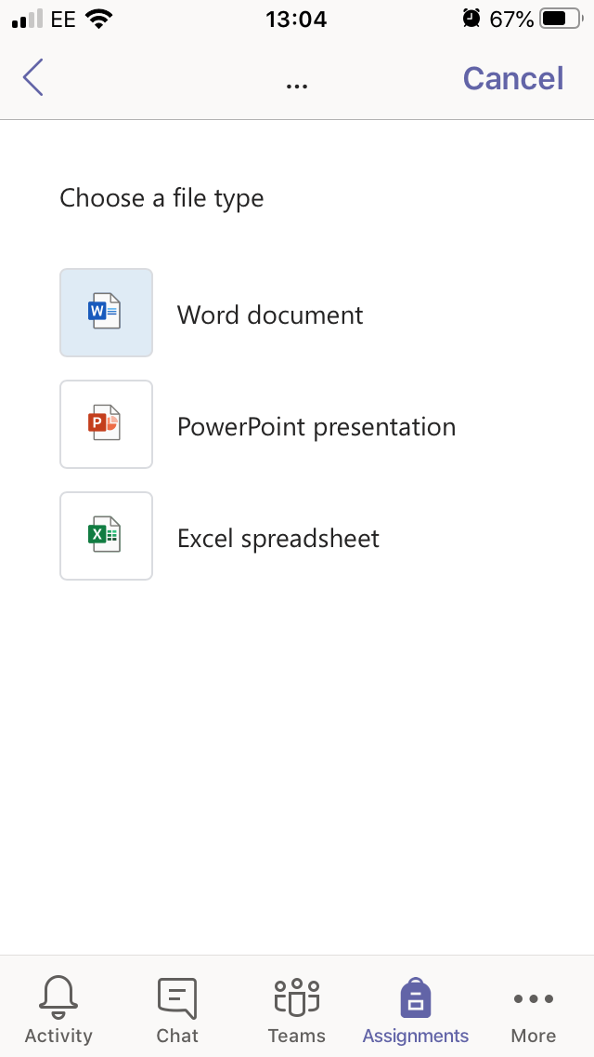

**If pupils click ‘+ New file’ this appears.** To open a new word document so that pupils can type answers, pupils click on Word Document. To open a new PowerPoint document, pupils click on PowerPoint presentation and so on.

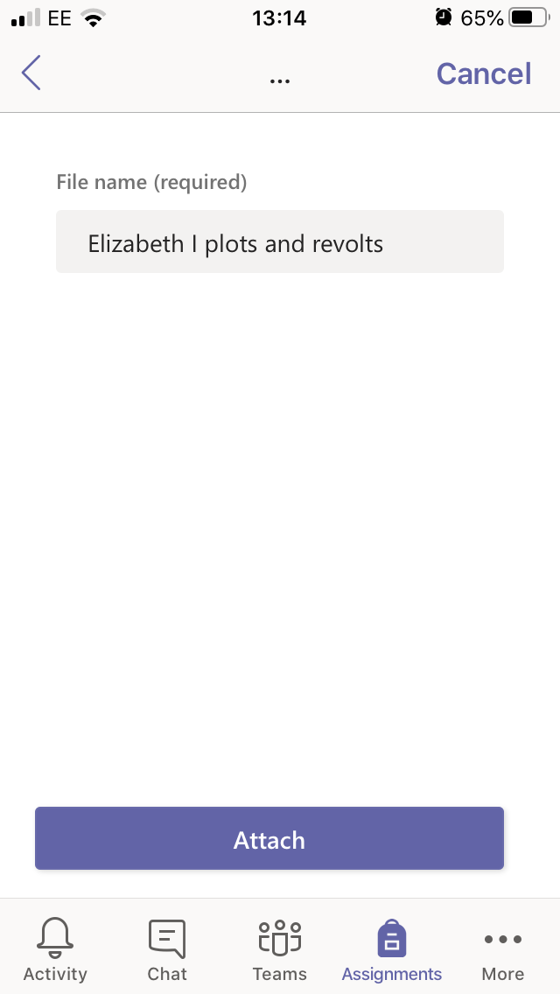

Once they open a new document they will need to give the document a name. Please make this name the same as the assignment and so teachers know which is the correct piece of work. You then click Attach. This has now been added to the assignment.

To write on the document, click on it and then the edit button in the top right hand corner. There is no need to save work as Teams saves work automatically. Pupils have access to Microsoft through their school accounts and so if it is not on their device already, they can download it for free.

To submit work to their teachers, pupils now MUST click the ‘hand in’ link. If they do not do this then the work will not be submitted.

To delete the document if it is wrong pupils can click the 3 dots at the side and ‘Remove’ it.

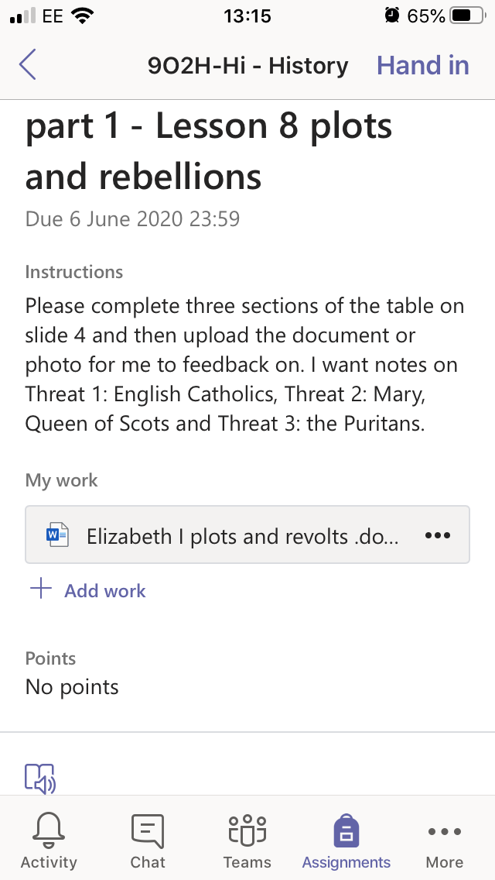

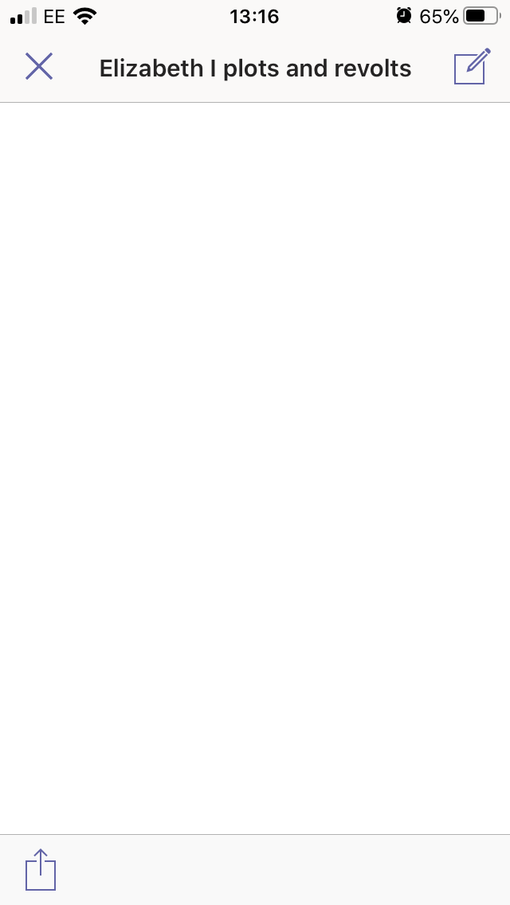



**If pupils click ‘Upload file from this device this appears**

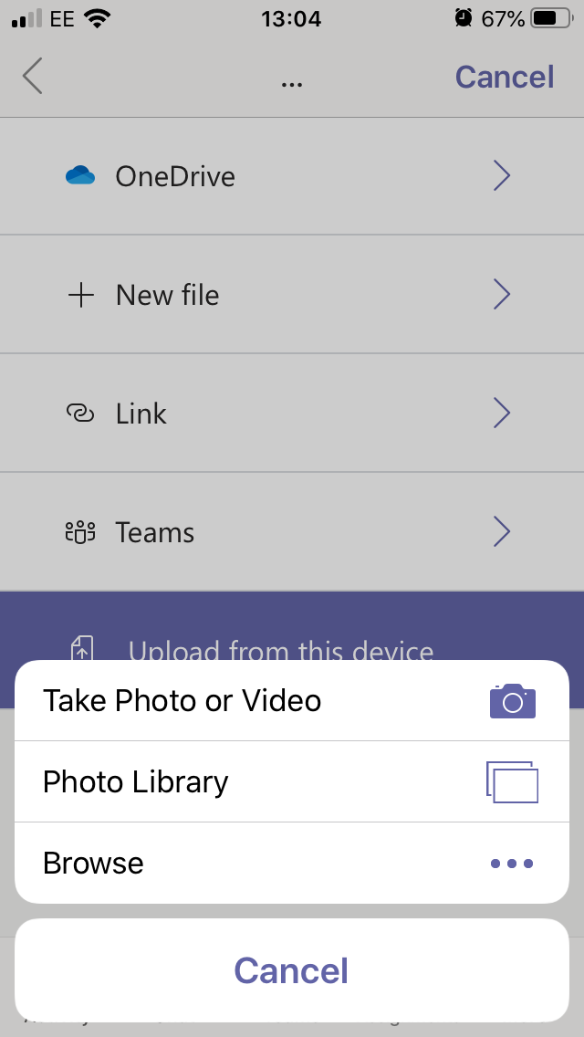

This is how pupils can take a photo of their written work and send it to their teacher.

If they select ‘Take a photo or video’, pupils MUST NOT TAKE A VIDEO only a photo. They take their photo in the normal way.

Click use photo and it will upload automatically.

The photo will appear as an image in the assignments page.

To submit work to their teachers, pupils now MUST click the ‘hand in’ link. If they do not do this then the work will not be submitted.

To delete the document if it is wrong pupils can click the 3 dots at the side and ‘Remove’ it.

