Help guide 4: Reading and sending emails through Microsoft 365
https://www.st-maryshigh.lancs.sch.uk/curriculum1/bsm-at-home/
On the school website, on the main home page, click in the top right hand corner where it says Office 365.
This link takes you to your email account link, one drive where you can store documents and the Teams link.

Once you have clicked on the Office 365 link it will take to a window which asks for your email address. THIS IS YOUR SCHOOL EMAIL ADDRESS. (A pupils email address is usually the year they started at Brownedge for example if they started in 2017, then it will be 17, followed by their surname and then the initial for their first name. For example 03maultt@st-maryshigh.lancs.sch.uk) It will then ask you for your password. THIS IS YOUR SCHOOL EMAIL ADDRESS PASSWORD.
The pupils password is set by them and so is private.
If pupils do not know their account or password details then they will need to contact school or email ictrequest@st-maryshigh.lancs.sch.uk to find out what it is or get it reset.

Once a pupil has logged on then this screen appears. If they need their email then they click on Outlook and if they want to go onto Teams they click Teams.
If a pupil clicks on Outlook it will automatically take them to their Inbox. This is the page where all of the emails they have received are.

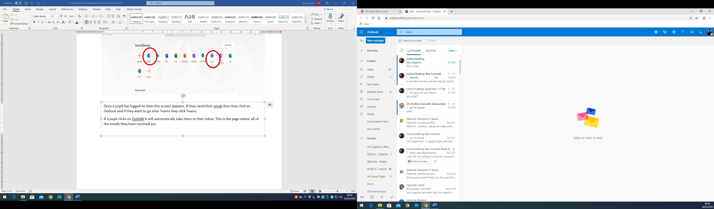
To read an email pupils just need to click on the message. Once the message is opened and can be read, a pupil can reply to it by clicking on a link on the right hand side.
In this order the symbols mean:
- Thumbs up = you like the message
- One arrow pointing left = reply to the person who sent the email
- Two arrows pointing left = reply to all people involved in the email
- One arrow pointing right = forward it to another person, send the email on to someone else.
To send an email pupils are to stay on the Inbox page and click on New message in the top left hand corner.
This screen below will then appear. Where it says ‘To’ pupils are to type in the email address of the person they wish to send the email to. This will be their teachers and the email addresses for staff are in the pupil planners, they are usually the member of staffs surname followed by their initial and the @st-maryshigh.lancs.sch.uk.
Pupils should then then give the email a subject, for example the name of their work, or a summary of the help they need. DO NOT WRITE THE WHOLE MESSAGE IN THE ADD A SUBJECT BOX.
The message they wish to send should then be written in the box underneath the subject.
- To send an email once it has been written pupils click the send link with the arrow
- To delete a message pupils click the Discard link with the bin
- To attach a document or photograph pupils click the Attach link with a paper clip (Please see below how to do this)
To attach a document, pupils click on the paperclip link. This could be pupils adding a worksheet, word document, PowerPoint or an image of work. Once they have done this, they have the option of what to attach and from where.
If pupils have saved the document on their device or on a pen drive/USB then they can select the document they want. Once they have selected it then they click open and it will attach to the email.

Once the file has been attached it will appear on the email

