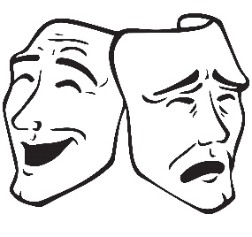
DRAMA VITAL VOCAB

TIER 1 | TIER 2 | TIER 3
Listening | Negotiation | Structure
Co-operation | Improvisation | Exposition
Communication | Characterisation | Rising action
Concentration | Audience | Climax
Volume | Levels | Falling action
Tone | Dialogue | Denouement
Pitch | Monologue | Proxemics
Accent | Rehearsal | Naturalism
Pace/tempo | Freeze frame | Realism
Facial expression | Thought tracking | Symbolism
Movement | Conscience alley | Proscenium stage
Posture | Flashback | Theatre in the round
Gesture | Narration | End on stage
Pause | Interaction | Thrust stage
Focus | Motivation | Promenade stage

